# Assignment 2 – Polynomial Interpolation

## Plot 1001 evenly spaced points of $e^{x}$ on $[0,2]$.

This experiment involves various methods of polynomial interpolation of the function $y=e^{x}$ such that $x∈[0,2]$ using the MATLAB software on my personal machine using a 2nd generation Intel i5 processor. The plot below shows a baseline plot of the function over the domain.

## 

## Vandermonde Interpolation Accuracy

While using the Vandermonde matrix to approximate $e^{x}$ such that $x∈[0,2]$ I used two methods: linearly spaced points and Chebyshev spaced points. The number of points varied from 6 to 641 given by $n_{i}=1+5{\left(2\right)}^{i-1},$ for $i=1, …,8$ and had their accuracy evaluated using the infinity and two norms. Chebyshev points were given by:

$$x_{i}=1-\cos\left(\frac{π\left(i-1\right)}{n-1}\right) for i=1, …, n$$

For lower values of $n$, such as 6, 11, 21, accuracy increased by up to 11 orders of magnitude for both methods. The linearly spaced points had a peak accuracy of $6.04x{10}^{-14}$ at $n=161$ while the Chebyshev spaced points had a peak accuracy of $1.78{x10}^{-15}$ at $n=21$.

## Polynomial and Barycentric Lagrange Interpolation Accuracy

Identical point spacing methods were used to evaluate Polynomial and Barycentric Lagrange interpolative methods. Results of note include the accuracy of the Chebyshev-spaced Polynomial method. As $n$ increased, the error ballooned reaching $5.08 x {10}^{172}$ at $n=641.$ The even spaced Polynomial method had a peak accuracy of $7.99 x {10}^{-15}$ at $n=21$ and remained relatively stable thereafter.

Even spaced Barycentric Lagrange also had ballooning error, greater than 1, after $n=21$. Chebyshev-spaced Barycentric had much better error peaking at $2.66x{10}^{-15}$ at $n=21$, while remaining stable after.

## Cubic Spline Interpolation Accuracy

The error for the Cubic Spline interpolation was relatively similar for both methods. They improved several magnitudes over time generally reaching their peaks at $n=641$. Peak error of $4.6 x {10}^{-12}$ for Chebyshev spacing and $1.38 x {10}^{-11}$ for evenly spaced.

## Timing and Accuracy

The various methods used in this experiment were timed and checked for error over the various $n$ values, the results are plotted below. The slowest methods were the Polynomial Lagrange methods, with the fastest being the Spline Methods. The most accurate methods were the Chebyshev spaced Barycentric Lagrange and Chebyshev Lagrange methods.

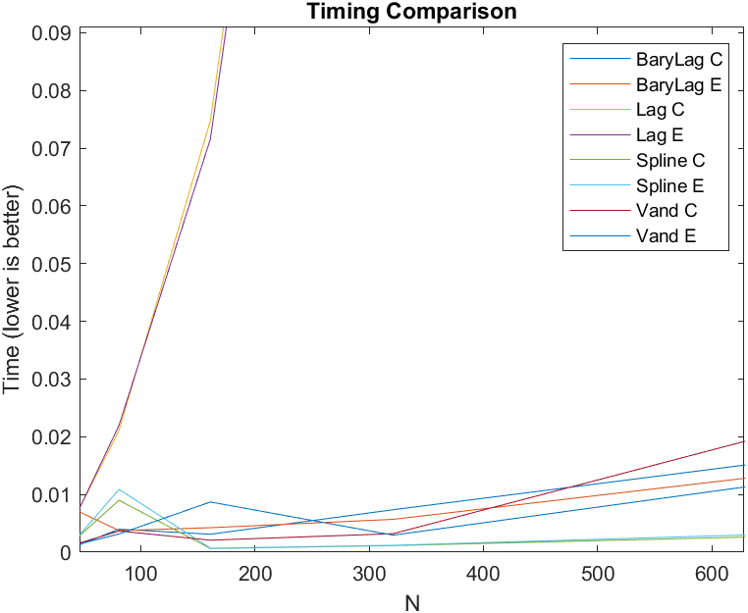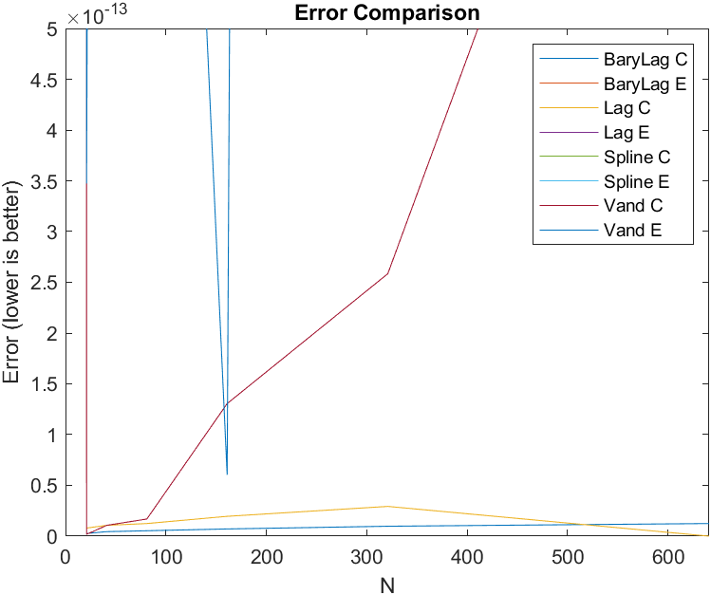

## Best Method

I believe the Spline methods are the best overall. They are the fastest as $n$ scales and retain reasonable accuracy levels of error ($x {10}^{-12} range$) as $n$ scales. I would also say that depending on your application, you may have varying tolerance for error and speed. Spline seems to give the best balance of both, point spacing methods seem negligible for this method.

## Code Inscrutability

Loops are particularly inefficient method of calculation for linear algebra applications so barylag.m has been vectorized to alleviate this inefficiency. This does lead to some difficulty in understanding what is going on. There are also some errors that have been left in the function header, probably for archival reasons. Leaving these past errors in just makes it harder to read in general.

## Conclusion

I found the comparison between the various methods quite interesting. In the applications I expect to work with, I expect I will be favoring speed the most with accuracy being an important but secondary characteristic. I am looking forward to learning additional modeling methods.